Edelweiss
GEdelweDiss, eGdelweCiss
GEvery mEMorning you Am7greet D7me
GSmall and Dwhite, clGean and brCight
GYou look D7happy to Gmeet me
DBlossom of snow may you Gbloom and grow
CBloom and gA7row, DforD7ever
GEdelwDeiss, eGdelweCiss
GBless my D7homeland Gforever

Have you ever seen the rain
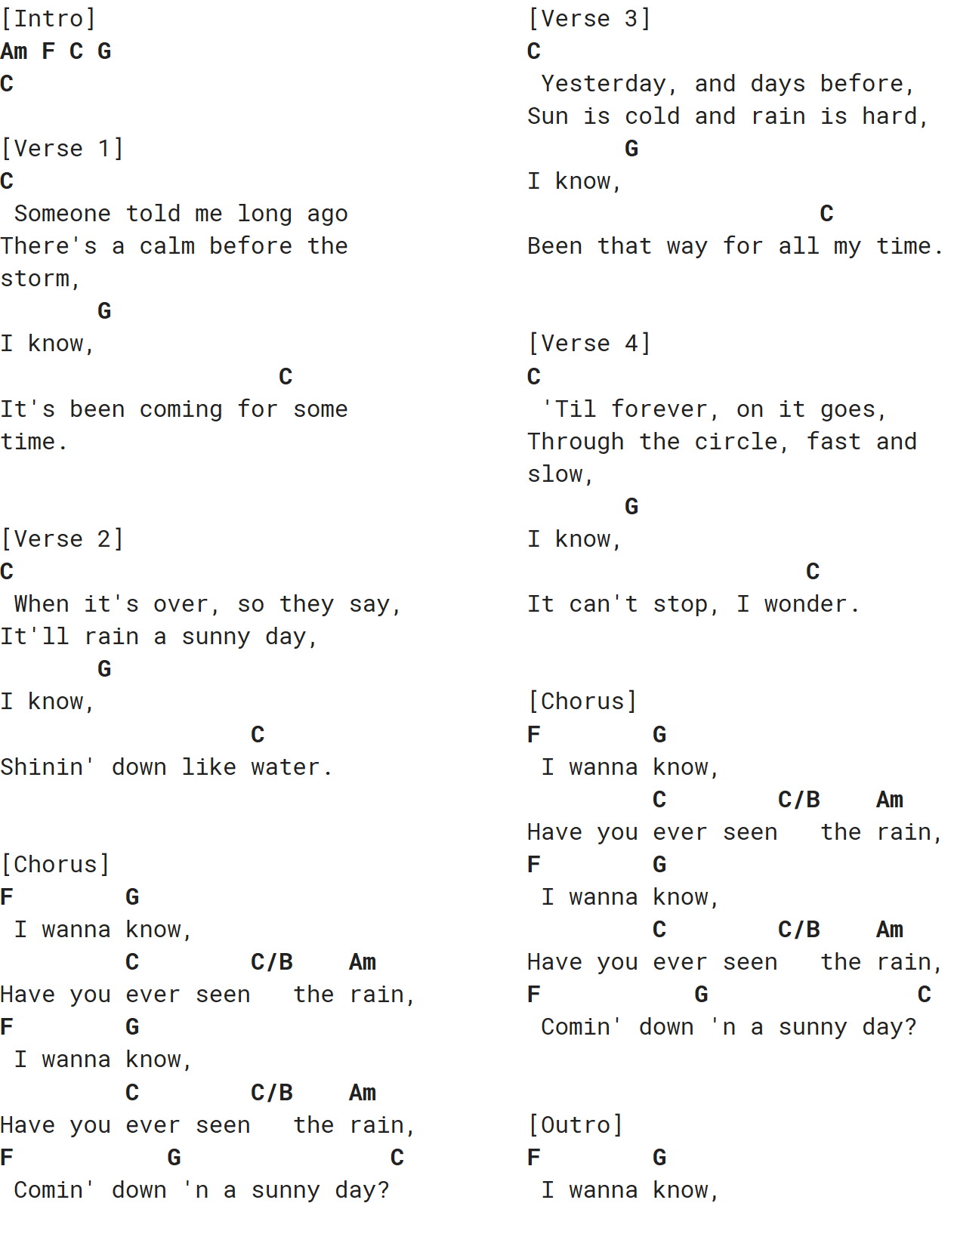
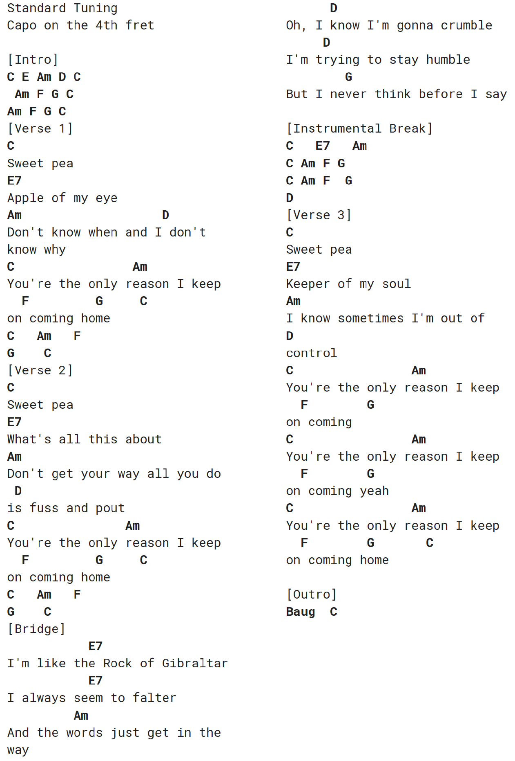

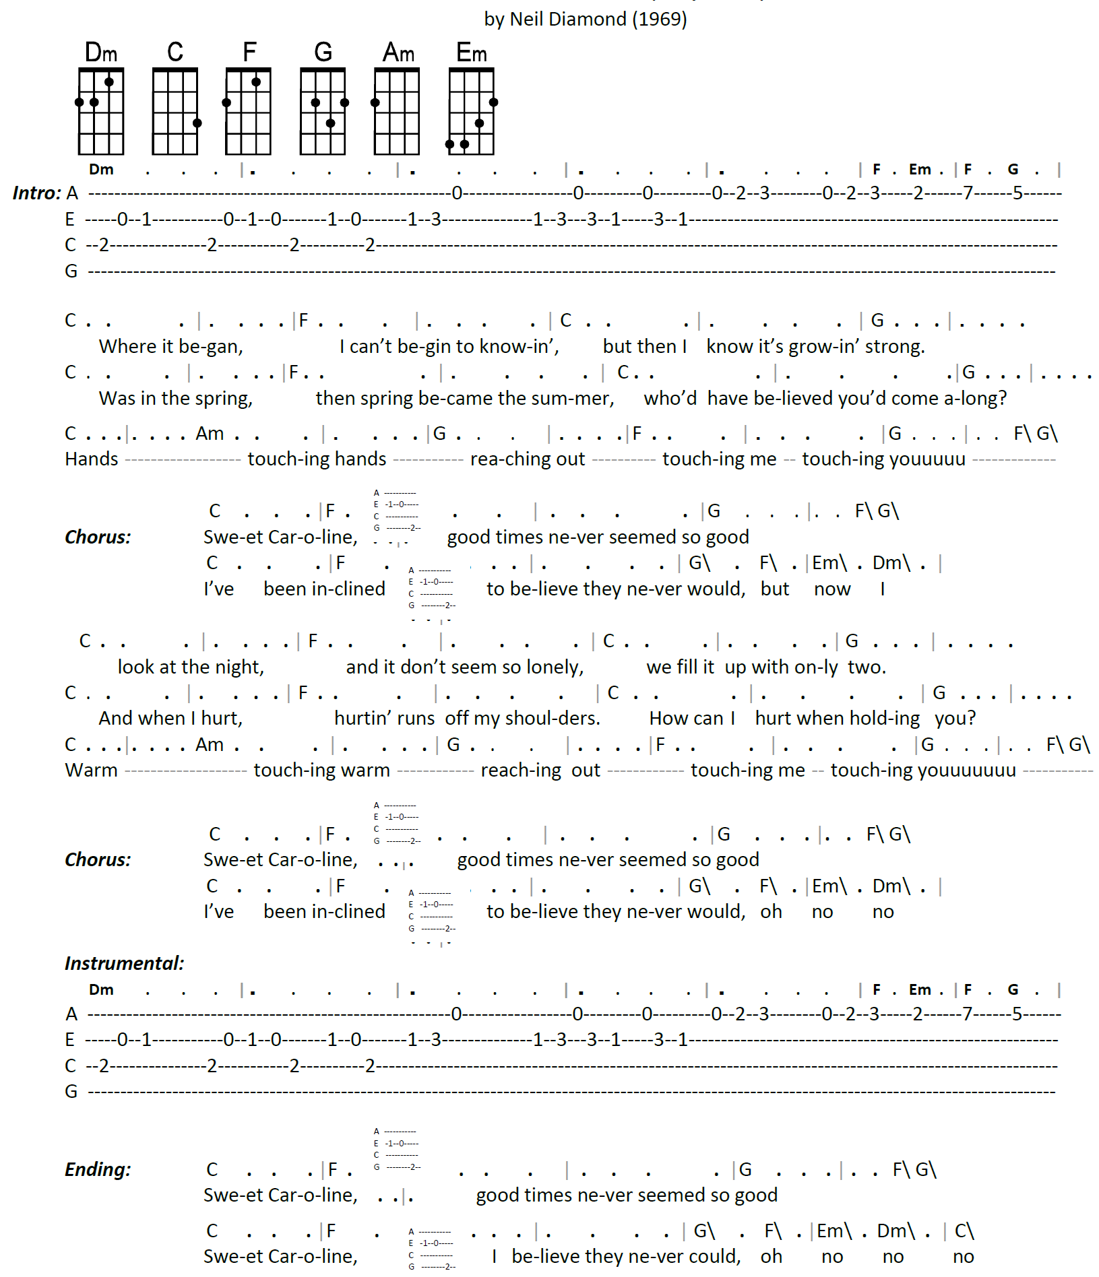

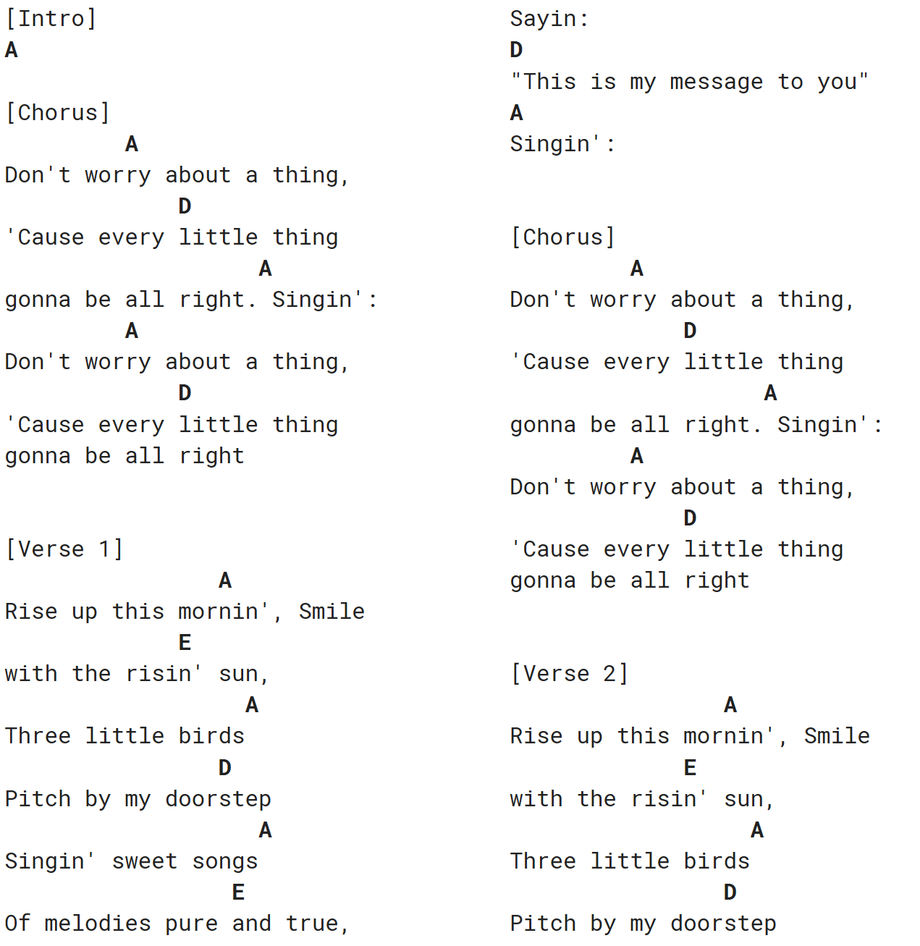

[verse 1]

G D
Oh the sun beats down and melts the tar upon the roof
D G G7
And your shoes get so hot you wish your tired feet were fire-proof
C G
Under the boardwalk, down by the sea
G D G
On a blanket with my baby is where I'll be

[verse 2]
G D
From a park nearby happy sounds from a carousel
D G G7
You can almost taste the hotdogs and french fries they sell
C G
Under the boardwalk, down by the sea
G D G
On a blanket with my baby is where I'll be

[bridge]
Em
Under the boardwalk, out of the sun
D
Under the boardwalk, we'll be having some fun
Em
Under the boardwalk, people walking above
D
Under the boardwalk, we'll be falling love
Em Em Em Em
Under the board-walk, board-walk

